
BNV COLLEGE OF TRACHER EDUCATION
GUIDANCE AND COUNSELLING CELL ‘DISHA’
And
SPIRITUAL CLUB ‘SHRADDHA’
YOGA DAY CELEBRATION
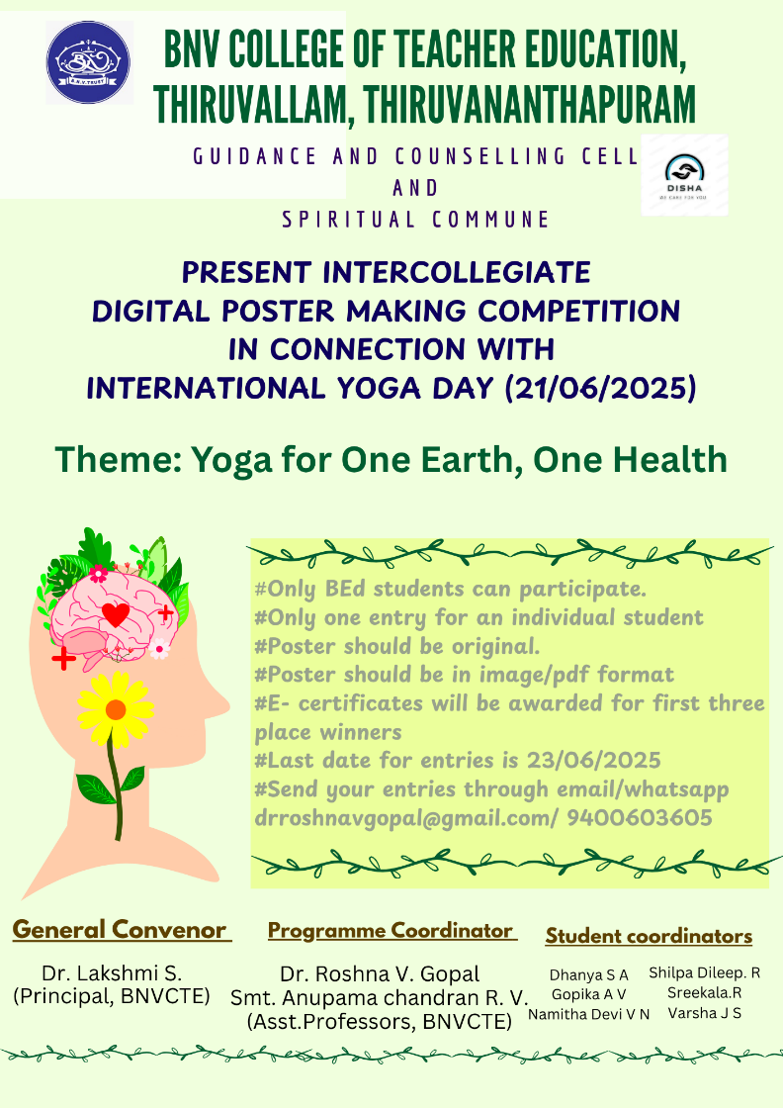

Guidance and counselling cell ‘DISHA’ and spiritual commune ‘SHRADDHA’ jointly celebrated International Yoga Day by conducting an intercollegiate digital poster making competition. The theme given for competition was ‘Yoga for One earth, One Health’.
The competition was enriched with the heartful participation of the student teachers from various teacher education colleges. Participants sent their entries through email and WhatsApp.
The list of colleges participated in the competition is given below
- Kaviyattu College of Education, Pirappancode
- SNGK BEd college, Pothencode
- PTM College of Education, Maruthoorkonam
- BNV College of Teacher Education, Thiruvallam
- Jamia Training College, Chithara

From many colleges more than one entry was received. The posters were good and conveyed the specific theme. Three judges were there in the judging panel to find the winners. Each entry was given chest number and given to the judges.
The judges were
- Dr. Rani K.V.
Certified yoga trainer and Assistant Professor
SNTC, Nedunganda, Varkala
- Dr. Swapna P.
Assistant professor, St. Jacobs’s Training College
Menamkulam, Thiruvananthapuram
- Mr. Satheesh G. Nair
Director Arts Space, Thiruvananthapuram

The judgement of the three judges was collaborated and found the winners of three places. Certificates also were provided to the winners.
The winners are
- Athira R. C. of PTM College of Education
- Neena S. Raj of BNV College of Teacher Education
- Lakshmi S. of Kaviyattu College of Education

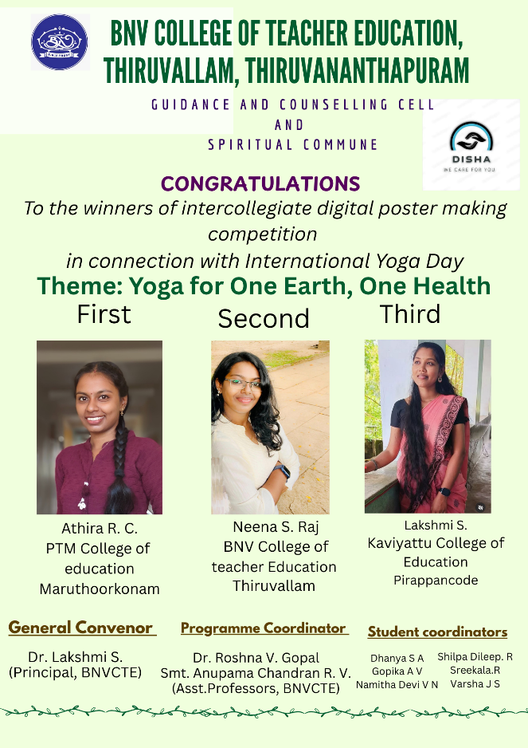
Winners First place winning poster

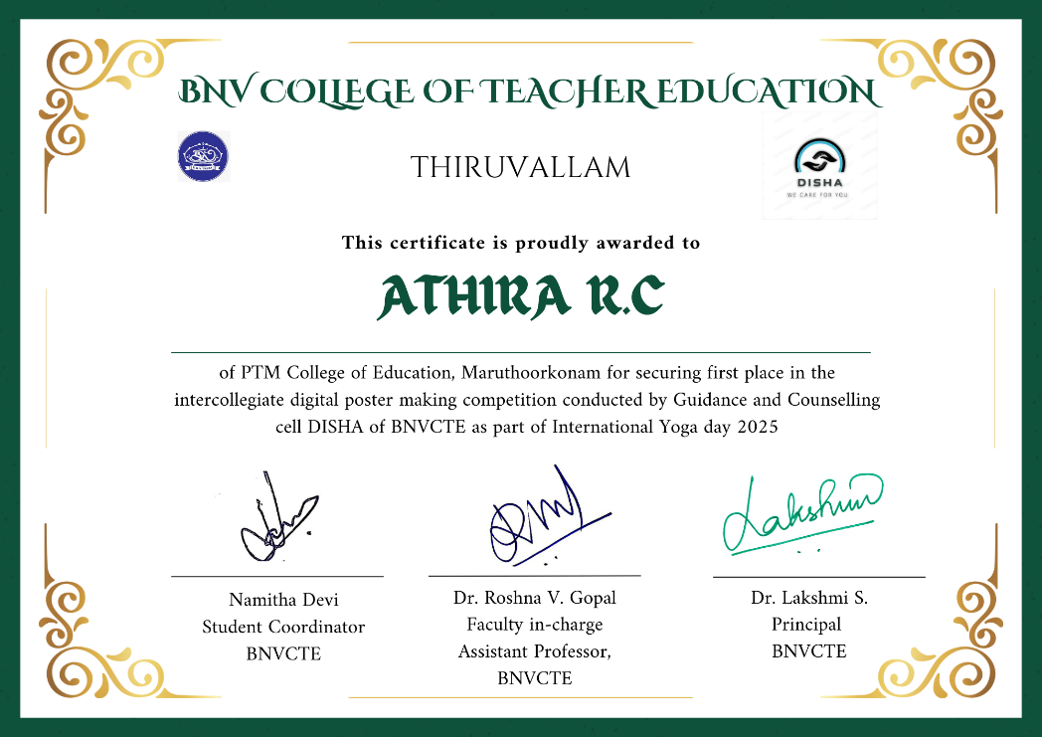
Certificate issued for 1st place winner

